Standard Operating Procedure for Magnetic Thermal Annealing (MTA)

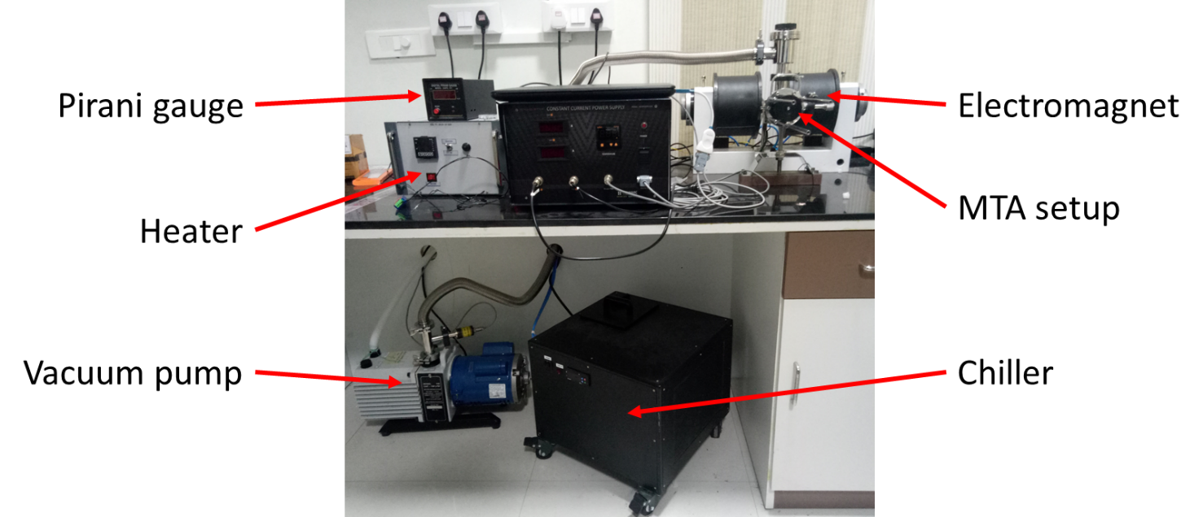

Figure 1: Magnetic Thermal Annealing Setup

Contents

Safety limits 2

Setting the MTA setup 2

Starting Procedure 2

Stopping procedure 3

Sample loading procedure 3

Electromagnet calibration 3

Constant Magnetic Field calibration 4

Setting Constant Magnetic Field 4

START and STOP the electromagnet using software 4

Electromagnet threshold temperature setup 5

Software bugs and how to rectify it 5

Temperature setup in heater 5

# Safety limits

1. Temperature at either of the poles should not exceed over ${70}^{0}C$ (at worst case ${75}^{0}C$)
2. The CCPS threshold should not be made more than ${65}^{0}C$
3. The heater temperature should not be made more than $400-{430}^{0}C$, otherwise the heat radiated by the heating chamber, makes the pole temperature go over ${70}^{0}C$
4. The chiller temperature should not be increased to higher degrees such as $8^{0}C or {10}^{0}C$, otherwise the electromagnet coil will heat up early
5. Pressure when vacuum pump is in the order of ${10}^{-2}$ mBar, if the pressure drops below $7×{10}^{-2}$ mBar, the Pirani gauge will read 0 mBar

# Setting the MTA setup

1. Calibrate your electromagnet (refer **ELECTROMAGNET CALIBRATION**)
2. Place your sample inside the tray of the MTA (refer **SAMPLE LOADING PROCEDURE**)
3. Make sure the sample is in between the poles (circular poles) inside the heating chamber
4. Place the heating chamber of the MTA between the poles of the electromagnet, make sure the heating chamber does not touch the pole
5. Make sure the vacuum pump is connected to the MTA and the vacuum pump outlet outside the room is open
6. Place two thermometers touching the pole to monitor the pole temperature (make sure they do not touch the heating chamber, refer **SAFETY LIMITS (Pt. 1 and 3)**)
7. Check if the heater is connected to the MTA, the chiller and the CCPS are connected to the electromagnet
8. Finally, make the room temperature close to $21-{22}^{0}C$ (change the AC temperature)

# Starting Procedure

1. Switch on the chiller main and the chiller pump, set it to $1^{0}C$ and start the chiller 30 min prior to the experiment
2. In the meantime, switch on the heater main and program the heater PID for heating for 1 Hr. at ${400}^{0}C$ (refer **TEMPERATURE SETUP IN HEATER**)
3. Once the chiller temperature reaches $1^{0}C$, switch on the Pirani gauge (to monitor the pressure inside the MTA, refer **SAFETY LIMITS (Pt. 5)**)
4. Close the right-angle valve at the top of the MTA, start the vacuum pump, once the Pirani gauge reading shows in the order of ${10}^{-2}$, open the right-angel valve (make sure the vacuum pump and the Pirani gauge runs throughout the experiment)
5. Now start the heater by pressing ↑ arrow on the heater PID, then switch on the heater toggle button
6. Once the heater reaches the temperature ${400}^{0}C$, switch on the CCPS and start the electromagnet through software
7. Set the magnetic field to $400$ mT, iz. 68% PWM (refer **CONSTANT MAGNETIC FIELD CALIBRATION)**
8. Make sure to set the CCPS threshold temperature to ${65}^{0}C$, constantly monitor the CCPS temperature reading (refer **SAFETY LIMITS (Pt. 2)**)
9. Now it will run for 1Hr. before the CCPS temperature reading shows close to ${65}^{0}C$
10. Throughout the procedure keep an eye on the pole temperatures, if it reaches ${75}^{0}C$ in either of the pole begin the **EMERGENCY GUIDELINES**

# Stopping procedure

1. After the experiment is conducted, stop the heater by pressing ↓ arrow key then press SET (while continually pressing ↓ arrow key)
2. Then switch of the heater toggle switch, do not switch off the heater main button (so that the heater temperature can be monitor)
3. Stop the electromagnet through the software, do not switch of the CCPS main (so that the electromagnet temperature can be monitor)
4. Stop the vacuum pump and close its outlet outside the room
5. EM and Heater will cool down on its own (without chiller), just make sure the AC is running
6. Once the heater temperature and the electromagnet temperature are reduced to room temperature, switch of the heater’s main and power, switch of the CCPS’s main and power
7. Then safely remove the sample from the MTA

**Generally, the EM takes 50-55 min to reach ${20}^{0}C$ from ${65}^{0}C$ while chiller is still running, even if the chiller is stopped, just switching of the CCPS mains will safely decrease the temperature to room temperature (make sure the AC is turned on), similar is the case for heater**

# Sample loading procedure

1. Take out the sample holder from the MTA by un-screwing
2. Handel it carefully, so that you don’t bend any of the rods
3. Mount your sample on the tray, with help of screws

# Electromagnet calibration

1. Connect the RS-232 Cable to the LAB PC
2. Open the EM controller application on the LAB PC
3. Select the calibration tab, and then click on ‘calibrate’ button under ‘Constant Current’ label
4. To observe the hysteresis plot, click on the ‘→’ arrow on the top-right corner of the software
5. Wait for some time until the process completed popup

# Constant Magnetic Field calibration

1. Select the calibration tab on the EM controller application
2. Place the gauss probe exactly in the middle in between the poles of the electromagnet
3. Set 400mT (or any other required value) in the constant field and click set
4. Wait until it shows some magnetic field value on the top (in red color)
5. Click update on sample position and wait until ‘successfully updated’ popup
6. Change your probe to some other position (not necessary, it can also be placed at the same position)
7. Click on update in ‘current position’ and wait until ‘successfully updated’ popup (it will show the magnetic field at current position, if the probe is not changed it will show 400mT or whatever value you have set)
8. Click on calibrate and wait until magnetic field ‘successfully calibrated’ popup

# Setting Constant Magnetic Field

1. Go to the measurement tab in the EM controller application
2. Make sure the ‘Magneticfield mode’ is set to ‘Constant_Current’
3. Under ‘Single Magneticfield’ label, check the ‘PWM’ box
4. Now if PWM% is set 100% it will give 500mT (or whatever value set during **CONSTANT MAGNETIC FIELD CALIBRATION**)
5. If you want to have a constant magnetic field of 400mT set, the PWM% to %

# START and STOP the electromagnet using software

Make sure the RS-232 is connected

1. After **ELECTROMAGNET CALIBRATION, CONSTANT MAGNETIC FIELD CALIBRATION** and **SETTING CONSTANT MAGNETIC FIELD**
2. Click the set button under the PWM, now the electromagnet will start
3. To stop the electromagnet, click on the stop button, which will be appearing under PWM

# Electromagnet threshold temperature setup

1. Hold the set button (yellow square button) of CCPS, while holding the set button, press ↑ arrow or ↓arrow to increase or decrease the threshold temperature of the CCPS (if the electromagnet temperature goes over the threshold the CCPS will cutoff)

# Software bugs and how to rectify it

1. EM SOFTWARE APPLICATION
   1. When the EM starts running, sometimes the magnetic field reading from the systems gaussmeter shows ‘-2500 mT’, to measure the actual reading use the labs Gauss probe and Gaussmeter
   2. When laptop screen goes to sleep mode, EM controller application does not responds, make sure to change the sleep time of screen to never, before starting the experiment
2. TEMPERATURE APPLICATION
   1. Does not have a start/stop button in the software (iz. To start/stop the heater, we have to manually operate the heater by the physical switch on the heater)

# Temperature setup in heater

The procedure shows the steps to set the temperature in the heater through the software

1. Switch on the power of the heater, switch on the main but do not turn on the heater toggle switch
2. Connect the RS485 converter (USB) to the laptop and then open the ‘temperature’ application
3. Make sure you are in the monitor tab (at the bottom), press the ‘communication’ button
4. The ‘communication setting’ pop-ups, make sure the following are checked:
   1. Scan all controllers
   2. MODBUS_RTU
   3. RS485 Converter (2 wires)
5. Close the ‘communication settings’, then press the ‘start’ button, then the controller 1 will start showing the PV and SV values of the heater (iz. Communication successful)
6. Goal is to run the heater at ${400}^{0}C$ for 2 hours, procedure to set:
   1. At first we need to go from room temperature to ${400}^{0}C$ in 15 min (don’t reduce this duration to very low value)
   2. Then we will maintain the temperature at ${400}^{0}C$ for 2 hours
   3. Then we will reduce the temperature to 200 in 10 min, then to 100 in 5 min, then to 30 in 2 min
7. To achieve the above goal, click the ‘Set’ button on controller 1, the ‘set controller’ window will pop-up, then select the ‘Program 1’ tab
   1. To achieve 6(a): Click on drop-down box, select SV_1 and set it to 400 (after every input, press ‘write’ button for all the steps in 8th Point), then again click on the drop-down box, select TM_1 and set it to 15 min, again click on drop-down box, select OUT_1 and set it to 75
   2. To achieve 6(b): Click on drop-down box, select SV_2 and set it to 400, then again click on the drop-down box, select TM_2 and set it to 2 hrs, again click on drop-down box, select OUT_2 and set it to 75
   3. To achieve 6(c): Set
      1. SV_3 → 200, TM_3 → 10 min, OUT_3 → 75, then set
      2. SV_4 → 100, TM_4 → 5 min, OUT_4→ 75, then
      3. SV_5 → 30, TM_5 → 2 min, OUT_5 → 75
8. Once the PID is programmed, press the ↑ arrow on the heater, to begin heating, then switch on the heater toggle switch